EENG 284

–

Digital Design Lab

Lab 5

–

The Guessing Game with Hints

Lab Solutions

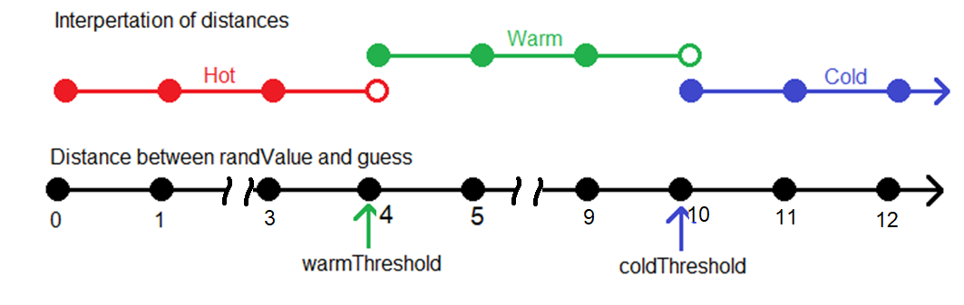

**The Guessing Game with Hints**

~~Table 1: Determine the quality of a guess at the secret number. Some of your answers may need to be a range (or two ranges) of values. Assume a 7-bit word size for guess and the secret number.~~

|  |  |  |  |
| --- | --- | --- | --- |
| *~~guess~~* | *~~secret number~~* | ~~difference~~ | ~~Quality~~ |
| ~~43~~ | ~~45~~ | **~~2~~** | **~~Hot~~** |
| ~~43~~ | ~~40~~ | **~~3~~** | **~~Hot~~** |
| ~~43~~ | ~~47~~ | **~~4~~** | **~~Warm~~** |
| ~~43~~ | **~~37~~** | ~~6~~ | ~~Cold~~ |
| **~~[48-50] or [40-42]~~** | ~~45~~ | ~~[3-5]~~ | ~~Warm~~ |
| **~~[0-39] or [51-128]~~** | ~~45~~ | ~~6+~~ | ~~Cold~~ |

Table 1: Determine the quality of a guess at the secret number. Your answer may be a number, pair of numbers, a range or a pair of ranges. Assume a 4-bit word size for guess and the secret number and warmThreshold = 4 and ColdThreshold=10.

|  |  |  |  |
| --- | --- | --- | --- |
| *guess* | *secret number* | difference | Quality |
| 14 | 11 | **3** | **Hot** |
| 8 | 12 | **4** | **Warm** |
| 4 | 14 | **10** | **Cold** |
| 8 | **6 or 10** | 2 | Hot |
| **[0-4] or [12-15]** | 8 | [4-9] | Warm |
| **[12-15]** | 2 | 10+ | Cold |

# Discrete Logic block:

~~Table 2: Complete the following table to determine which comparator outputs are needed to determine the quality of a guess. Let warmThresh =3 and coldThresh = 6.~~

|  |  |  |  |  |  |  |  |  |  |
| --- | --- | --- | --- | --- | --- | --- | --- | --- | --- |
| *~~difference~~* | ~~warmThresh comparator~~ | | | ~~coldThresh comparator~~ | | | ~~Hot~~ | ~~Warm~~ | ~~Cold~~ |
| ~~wGT~~ | ~~wEQ~~ | ~~wLT~~ | ~~cGT~~ | ~~cEQ~~ | ~~cLT~~ |
| ~~1~~ |  |  | ~~1~~ |  |  | ~~1~~ | ~~1~~ |  |  |
| ~~2~~ |  |  | ~~1~~ |  |  | ~~1~~ | ~~1~~ |  |  |
| ~~3~~ |  | ~~1~~ |  |  |  | ~~1~~ |  | ~~1~~ |  |
| ~~4~~ | ~~1~~ |  |  |  |  | ~~1~~ |  | ~~1~~ |  |
| ~~5~~ | ~~1~~ |  |  |  |  | ~~1~~ |  | ~~1~~ |  |
| ~~6~~ | ~~1~~ |  |  |  | ~~1~~ |  |  |  | ~~1~~ |
| ~~7~~ | ~~1~~ |  |  | ~~1~~ |  |  |  |  | ~~1~~ |

Table 2: Complete the following table to determine which comparator outputs are needed to determine the quality of a guess. Let warmThresh =4 and coldThresh = 10.

|  |  |  |  |  |  |  |  |  |  |
| --- | --- | --- | --- | --- | --- | --- | --- | --- | --- |
| *difference* | warmThresh comparator | | | coldThresh comparator | | | Hot | Warm | Cold |
| wGT | wEQ | wLT | cGT | cEQ | cLT |
| 3 |  |  | 1 |  |  | 1 | 1 |  |  |
| 4 |  | 1 |  |  |  | 1 |  | 1 |  |
| 5 | 1 |  |  |  |  | 1 |  | 1 |  |
| 9 | 1 |  |  |  |  | 1 |  | 1 |  |
| 10 | 1 |  |  |  | 1 |  |  |  | 1 |
| 11 | 1 |  |  | 1 |  |  |  |  | 1 |

Cold = cGT | cEQ

Warm = cLT & (wGT | wEQ)

Hot = wLT

# hiLow_tb module:

Table 3: The values used in the hotCold testbench. With warmThreshold = 4 and coldThreshold = 10

|  |  |  |  |  |  |  |  |
| --- | --- | --- | --- | --- | --- | --- | --- |
| Test | seed | randNum | guess | big | small | Difference | Comment |
| 1 | 4’b101010 | 4’b0100 4 | 4’b111115 | 4’b111115 | 4’b01004 | 4’b101111 | +11 Cold |
| 2 | 4’b1110 14 | 4’b111014 | 4’b101010 | +10 Cold |
| 3 | 4’b1101 13 | 4’b110113 | 4’b10019 | +9 Warm |
| 4 | 4’b1000 8 | 4’b10008 | 4’b01004 | +4 Warm |
| 5 | 4’b01117 | 4’b01117 | 4’b00113 | +3 Hot |
| 6 | 4’b111115 | 4’b111014 | 4’b00113 | 4’b111014 | 4’b00113 | 4’b101111 | -11 Cold |
| 7 | 4’b01004 | 4’b01004 | 4’b101010 | -10 Cold |
| 8 | 4’b01015 | 4’b01015 | 4’b10019 | -9 Warm |
| 9 | 4’b101010 | 4’b101010 | 4’b01004 | -4 Warm |
| 10 | 4’b101111 | 4’b101111 | 4’b00113 | -3 Hot |
| 11 | 4’b111014 | 4’b111014 | 4’b00000 | Equal Hot |

# Pin Assignment:

|  |  |  |  |
| --- | --- | --- | --- |
| Segment | randSeg | hotColdSeg | hiLowSeg |
| seg[6] | AC22 | AF24 | Y18 |
| seg[5] | AC23 | AC19 | Y19 |
| seg[4] | AC24 | AE25 | Y20 |
| seg[3] | AA22 | AE26 | W18 |
| seg[2] | AA23 | AB19 | V17 |
| seg[1] | Y23 | AD26 | V18 |
| seg[0] | Y24 | AA18 | V19 |

|  |  |  |  |
| --- | --- | --- | --- |
|  | seedSwitch | playSwitch | guessSwitch |
| slide[3] | AE19 | N/A | AC8 |
| slide[2] | Y11 | N/A | AD13 |
| slide[1] | AC10 | AB10 | AE10 |
| slide[0] | V10 | W11 | AC9 |

|  |  |  |
| --- | --- | --- |
| randBut | Key[3] | Y16 |
| hotColdBut | Key[2] | Y15 |
| hiLowBut | Key[0] | P11 |

|  |  |  |  |
| --- | --- | --- | --- |
| G[3] | G[2] | G[1] | G[0] |
| E9 | D8 | K6 | L7 |

When compete, your testbench should look like the timing diagram in Figure 7.

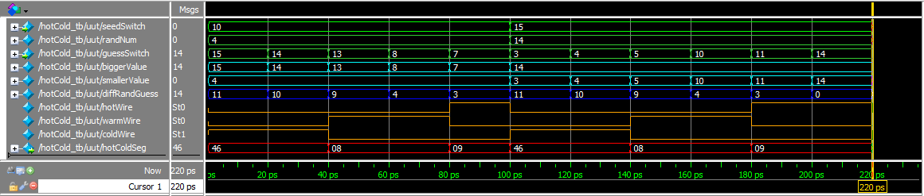

Figure 7: A timing diagram generated by the testbench.